BOC API Document
Awaiting Vendor Selection
“Add Current Location”:
- /api/v1.0/vendor/getAllActive
- /api/v1.0/customers/getAllActive

- “/api/v1.0/vendor/getAllActive”
Open “Front End” codebase”:
Search the API in “restURI.ts” file:
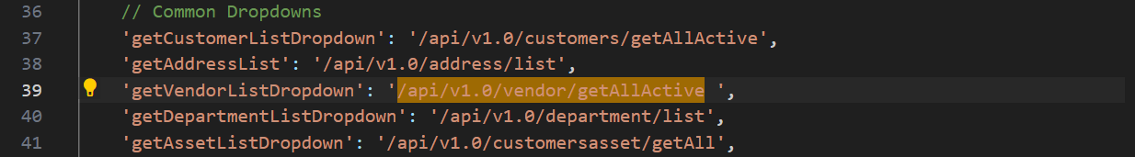
Copy: “getVendorListDropdown” to search in frontend.
Open “Back End” codebase:
Open “vendor.routes.js”,
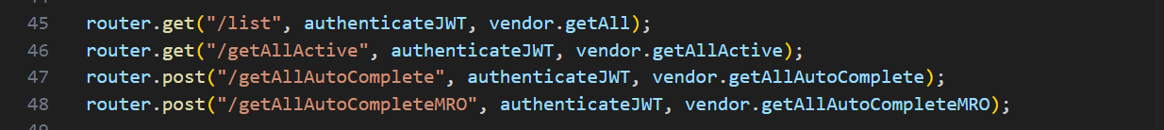
“Right” click on “vendor.getAllActive” in line 46, click “Go to Definition”, it shows the code in “vendor.controller.js”,
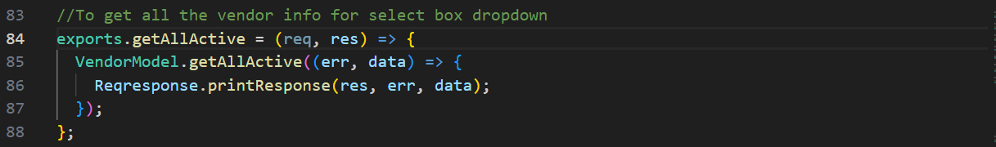
“Right” click on “getAllActive” in line 85, click “Go to Definition”, it shows its “SQL” codebase in “vendor.model.js” in line 258,
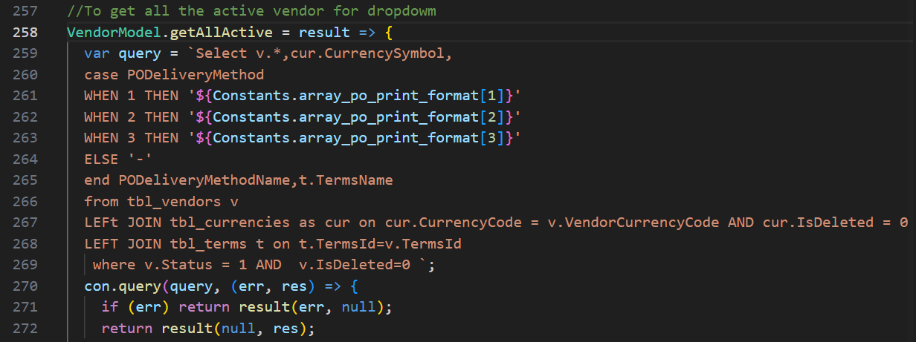
and so on.

- “/api/v1.0/customers/getAllActive”
Open “Front End” codebase”:
Search the API in “restURI.ts” file:
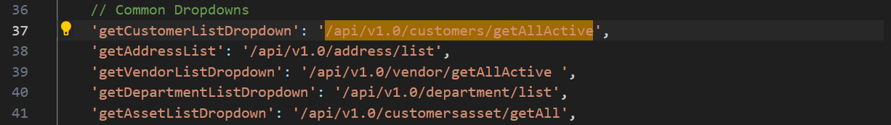
Copy: “getCustomerListDropdown” to search in frontend.
Open “Back End” codebase:
Open “customer.routes.js”,
“Right” click on “customer.getAllActive” in line 123, click “Go to Definition”, it shows the code in “customers.controller.js”,
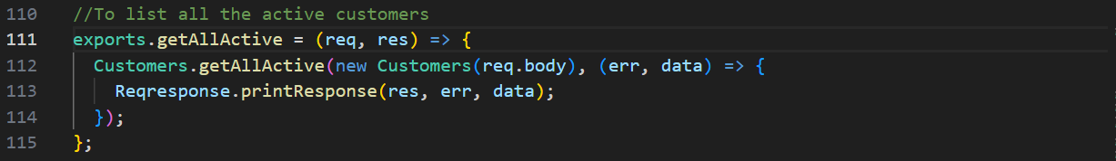
“Right” click on “getAllActive” in line 112, click “Go to Definition”, it shows its “SQL” codebase in “customers.model.js” in line 412,
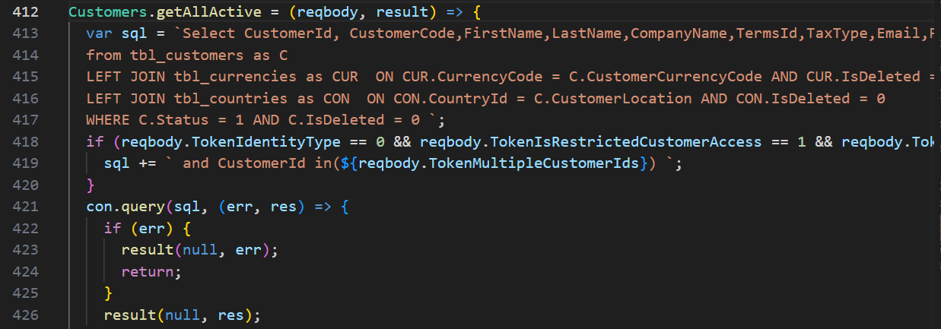
and so on.
“Part location: BOC”:
- /api/v1.0/address/list

- “/api/v1.0/address/list”
Open “Front End” codebase”:
Search the API in “restURI.ts” file:
Copy: “getAddressList” to search in frontend.
Open “Back End” codebase:
Open “customeraddress.routes.js”,
“Right” click on “Address.list” in line 20, click “Go to Definition”, it shows the code in “customeraddress.controller.js”,
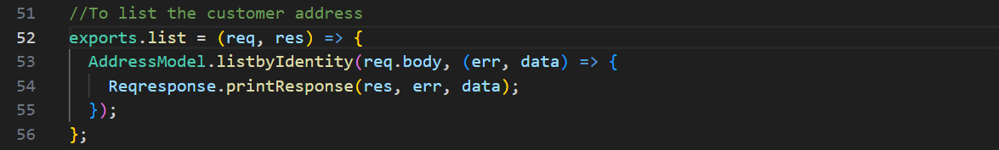
“Right” click on “listbyIdentity” in line 53, click “Go to Definition”, it shows its “SQL” codebase in “customeraddress.model.js” in line 170,
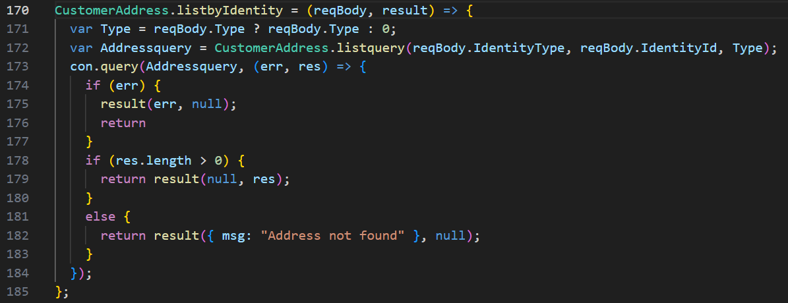
“Part location: AiBond”:
- /api/v1.0/address/GetAHGroupVendorAddress

- “/api/v1.0/address/GetAHGroupVendorAddress”
Open “Front End” codebase”:
Search the API in “restURI.ts” file:
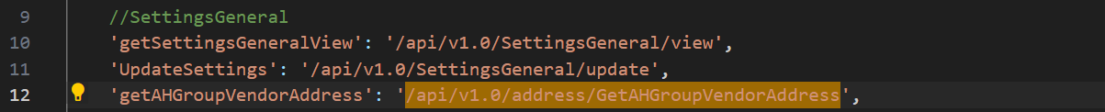
Copy: “getAHGroupVendorAddress” to search in frontend.
Open “Back End” codebase:
Open “customeraddress.routes.js”,
“Right” click on “Address.GetAHGroupVendorAddress” in line 23, click “Go to Definition”, it shows the code in “customeraddress.controller.js”,
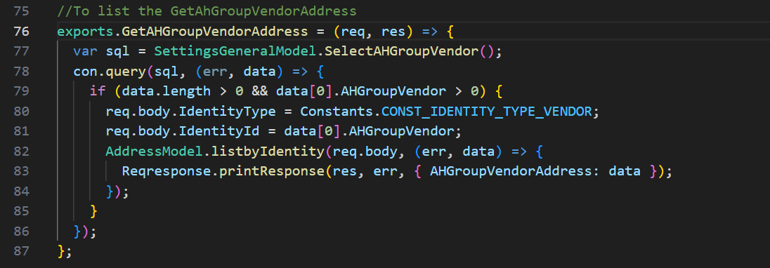
“Right” click on “SelectAHGroupVendor()” in line 77, click “Go to Definition”, it shows its “SQL” codebase in “settings.general.model.js” in line 178,
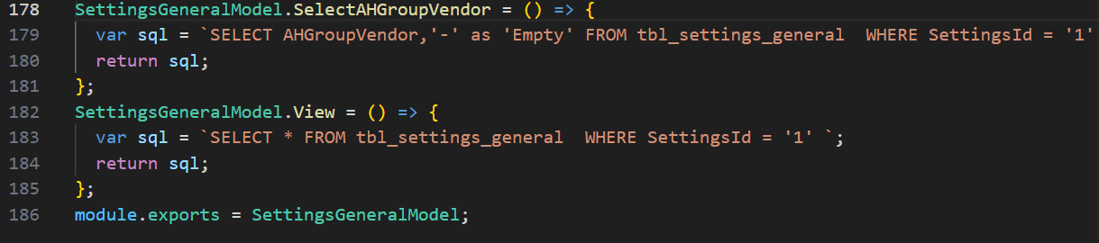
“Submit”:
- /api/v1.0/repairRequest/UpdatePartCurrentLocation
- /api/v1.0/notification/getLatest
- /api/v1.0/repairRequest/WorkchainMyTaskCount
- /api/v1.0/ecommerce/product/cartCount
- /api/v1.0/country/list
- /api/v1.0/repairRequest/view
- /users/getAllActiveAdmin
- /api/v1.0/RRSubStatus/dropdown
- /api/v1.0/currencyExchangeRate/exchange
- /api/v1.0/customerParts/list

- “/api/v1.0/repairRequest/UpdatePartCurrentLocation”
Open “Front End” codebase”:
Search the API in “restURI.ts” file:
Copy: “UpdatePartCurrentLocation” to search in frontend.
Open “Back End” codebase:
Open “repairrequest.routes.js”,
“Right” click on “RR.UpdatePartCurrentLocation” in line 49, click “Go to Definition”, it shows the code in “repairrequest.controller.js”,
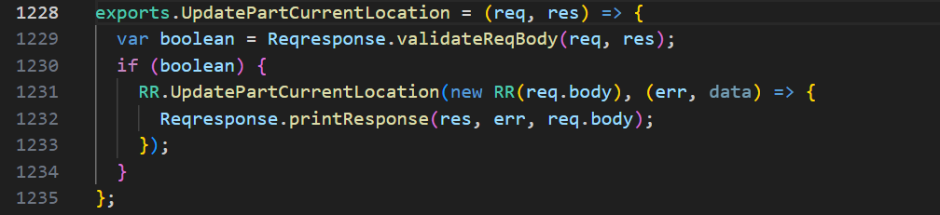
“Right” click on “UpdatePartCurrentLocation” in line 1231, click “Go to Definition”, it shows its “SQL” codebase in “repair.request.model.js” in line 3989,
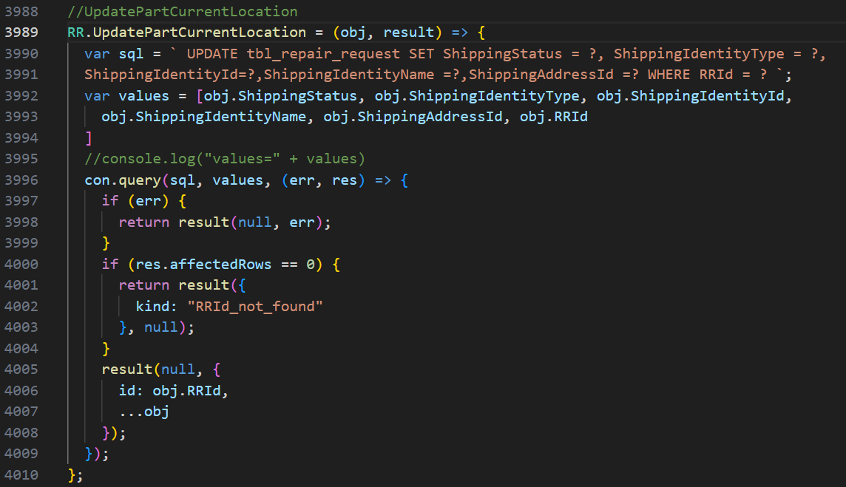
- “/api/v1.0/notification/getLatest”: Repeated
- “/api/v1.0/repairRequest/WorkchainMyTaskCount”: Repeated
- “/api/v1.0/ecommerce/product/cartCount”: Repeated
- “/api/v1.0/country/list”: Repeated
- “/api/v1.0/repairRequest/view”: Repeated
- “/users/getAllActiveAdmin”: Repeated
- “/api/v1.0/RRSubStatus/dropdown”: Repeated
- “/api/v1.0/currencyExchangeRate/exchange”: Repeated
- “/api/v1.0/customerParts/list”: Repeated
“Verify”:
- /api/v1.0/repairRequest/update
- /api/v1.0/notification/getLatest
- /api/v1.0/repairRequest/WorkchainMyTaskCount
- /api/v1.0/ecommerce/product/cartCount
- /api/v1.0/country/list
- /api/v1.0/repairRequest/view
- /users/getAllActiveAdmin
- /api/v1.0/RRSubStatus/dropdown
- /api/v1.0/currencyExchangeRate/exchange

- “/api/v1.0/repairRequest/update”
Open “Front End” codebase”:
Search the API in “restURI.ts” file:
Copy: “RepairRequestEdit” to search in frontend.
Open “Back End” codebase:
Open “repairrequest.routes.js”,
“Right” click on “RR.UpdateRepairRequest” in line 19, click “Go to Definition”, it shows the code in “repairrequest.controller.js”,
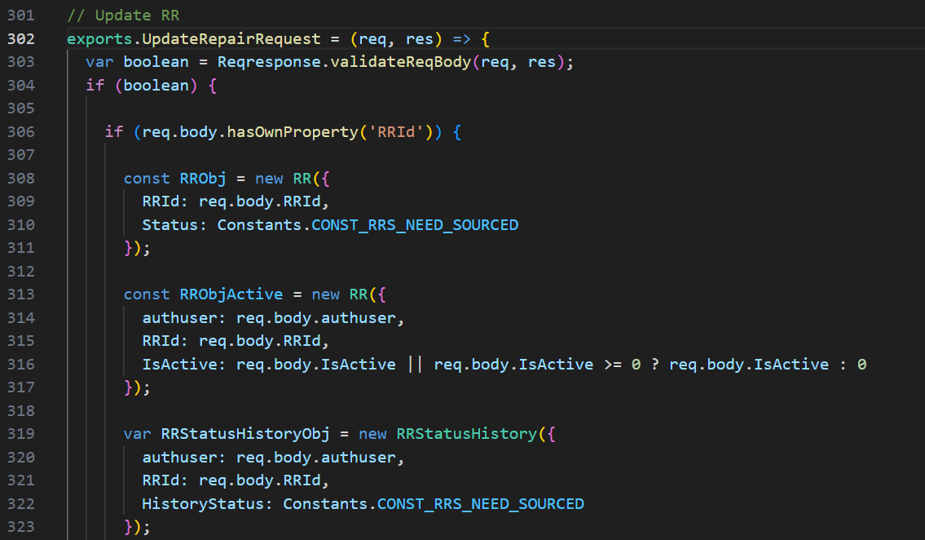
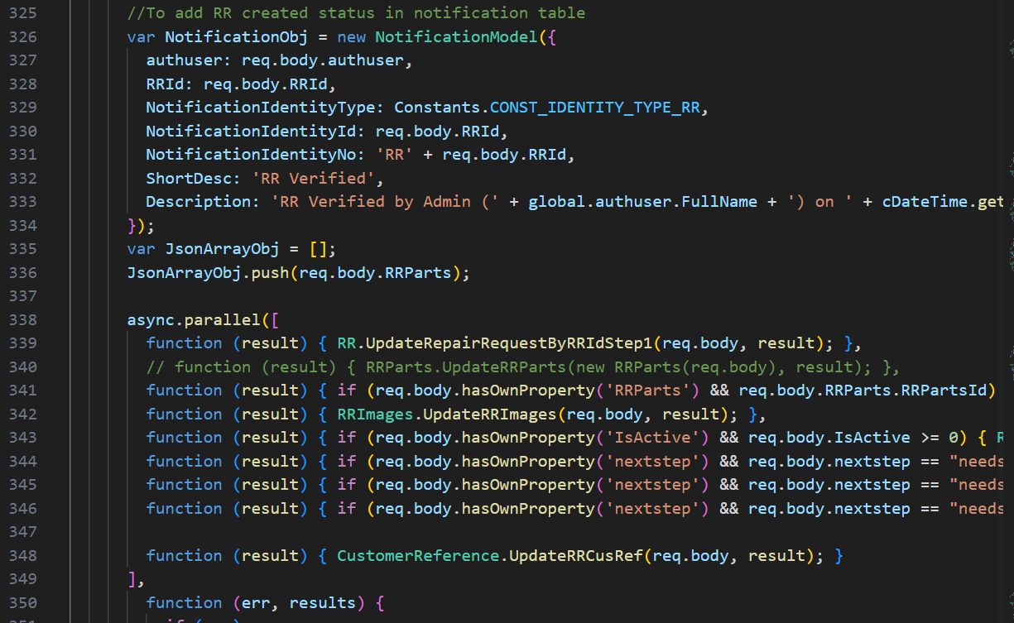
and so on.
“Right” click on “validateReqBody” in line 303, click “Go to Definition”, it shows its “SQL” codebase in “request.response.validation.js” in line 8,
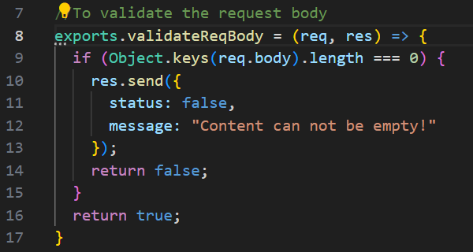
“Right” click on “UpdateRepairRequestByRRIdStep1” in line 339, click “Go to Definition”, it shows its “SQL” codebase in “repair.request.model.js” in line 376,
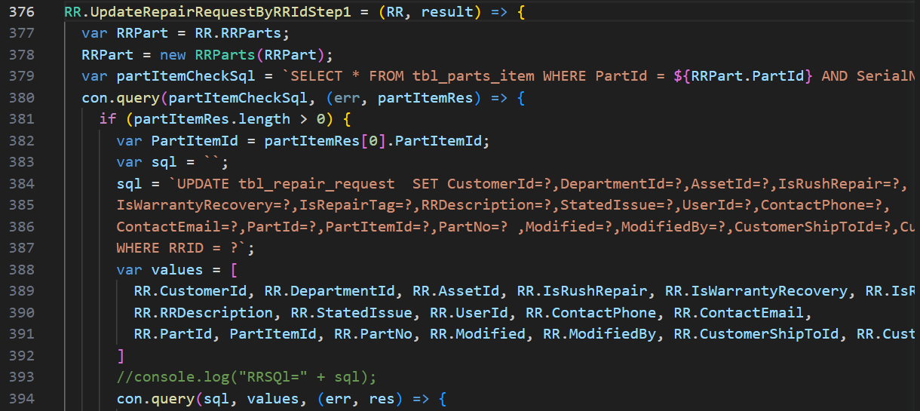
and so on.
- “/api/v1.0/notification/getLatest”: Repeated
- “/api/v1.0/repairRequest/WorkchainMyTaskCount”: Repeated
- “/api/v1.0/ecommerce/product/cartCount”: Repeated
- “/api/v1.0/country/list”: Repeated
- “/api/v1.0/repairRequest/view”: Repeated
- “/users/getAllActiveAdmin”: Repeated
- “/api/v1.0/RRSubStatus/dropdown”: Repeated
- “/api/v1.0/currencyExchangeRate/exchange”: Repeated

